Instructions and guidelines:

1. This is a team-based task. You need to work with your team members to complete this task.
2. Use the given template, in MS-Word format, to complete the requirements of this task.
3. Upload your completed document file, in PDF format, on Moodle.
4. One submission is needed by each team.

|  |  |
| --- | --- |
| **Course Learning Outcomes (CLO)** | |
| CLO1 | Define an application to design and implement. |
| CLO2 | Prepare a project proposal, which includes project statement, project’s objectives, a high-level plan for the project, including main phases, budget, and timeline. |

Task 2 – Software Requirements Specification

Use the following template to prepare your project requirements specification document.

|  |  |
| --- | --- |
| **Task:** | **Software Requirements Specification** |
| **Project Title:** | **Intelligent Autonomous Hoover as an IoT Solution** |
| **Team Members’ Names:** | 1. Nawaf Alzahem 2. Fahad Aldulaigan 3. Mohammad Abuhaimed 4. Khalid Abu Alsaud 5. Khalid Hali |
| **Supervisor Name:** | **Dr. George Violettas** |
| **Date:** | **20/10/2022** |

# Proposed System:

* 1. **: Overview**

1. The project is a wireless sensor network system consisting of Libelium sensor nodes that collect data from various sensors and transmit it to a central database. The system can monitor various environmental parameters such as temperature, humidity, air quality, noise level, and many more. The system is designed to be scalable, flexible, and energy-efficient, and provides real-time data to the users via a web-based interface.

2. Real-Time Face Recognition Android - The project is an Android-based application that uses computer vision algorithms to perform real-time face detection and recognition. The system uses a database of known faces to match against the detected faces and display their name or ID in real-time. The application can work in various lighting conditions, frame rates, and camera resolutions, making it suitable for use in diverse scenarios. The application is customizable, and users can adjust the algorithm's parameters to optimize the system's performance for their specific needs.

* 1. **: Functional Requirements**

**Libelium:**

1. The system should collect data from Libelium sensors related to temperature, humidity and pressure and send it to a central database.

2. The system should store the collected data in the database.

3. The system should allow users to set threshold values and provide alerts if the collected data goes beyond the set thresholds.

4. The system should provide a CLI interface to view the temperature, humidity, and pressure data in real-time in Waspmote.

5. The system should provide a continues results of the collected data over time.

6. The system should be scalable, flexible, and energy-efficient, and should provide real-time data to the users via a web-based interface.

7. The web-based interface should allow users to view real-time sensor readings, node status, and battery life.

8. d. The system should be able to detect sensor node malfunctions and send alerts to the system administrator.

9. The system should be able to detect data storage issues and alert the system administrator about it.

10. The system should be able to authenticate user credentials before allowing them access to the web-based interface.

**Android:**

1. The system should be able to capture real-time video feed using the mobile device's camera.

2. The system should be able to analyze and recognize faces in the captured images.

3. The system should be able to recognize faces in the video feed and match them against a pre-defined set of faces.

4. The system should be able to display the names of the recognized faces on the screen.

5. The system should be able to store the recognized faces' data in a database for future reference.

6. The system should be able to handle multiple users and recognize each of them accurately.

7. The user interface should display the name or ID of the recognized face in real-time.

8. The application should be able to add new faces to the database for future recognition.

9. The system should be able to detect multiple faces in the camera frame and identify each of them within a short period.

10. The application should be able to work under different lighting conditions, frame rates, and camera resolutions.

11. The application should have customizable algorithm parameters, enabling users to adjust the algorithm's performance according to their specific needs.

* 1. **: Non-Functional Requirements**

**Libelium:**

1. **Performance** - The system should provide real-time data with low latency and high accuracy.

2. **Reliability** - The system should be available for use at all times, with minimal downtime.

3. **Scalability** - The system should be easy to scale up or down depending on the number of nodes or sensors required.

4. **Security** - The system should have appropriate security measures in place to protect the data from unauthorized access, tampering, and theft.

5. **Usability** - The system should be easy to use, with a user-friendly web interface.

6. **Battery life** - The sensor nodes should have an extended battery life to minimize maintenance requirements.

7. **User Interface**: uses a web-based interface for displaying the real-time sensor data along with the visual representations of the sensor network and an interactive map.

8. **Documentation**: The project must have well-organized documentation that provides a detailed description of the project, its components, and its functionality.

9. **Hardware Considerations**: uses a Libelium Waspmote sensor network and Arduino microcontrollers. Suitable hardware for hosting the web-based interface and the database back-end must be chosen.

10. **Performance Characteristics**: The system processes sensor data in real-time and stores it in a database. The performance of the system is primarily dependent on the number of sensors and the rate at which the data is received. The system should be able to handle a large number of sensors and data rates.

11. **Error Handling and Extreme Conditions**: The system must handle sensor failures, missing data, and other error conditions. The system should also be designed to handle extreme weather conditions and power outages.

12. **System Interface**: The system consists of multiple components, including the sensor network, server, database, and web-based interface. The components must be integrated to ensure smooth communication between them.

13. **Quality Issues**: The system should provide high-quality data and user experience. It should be tested thoroughly to ensure optimal performance.

14. **System Modifications**: The system may need to be modified to accommodate changes in the sensor network, data rates, or other factors that could affect the system's performance.

15. **Physical Environment**: The system should be able to operate in a variety of environments, including indoor and outdoor environments. The system must be designed to withstand harsh conditions.

16. **Security Issues**: The system must be designed with security in mind to protect the sensor data and the user's privacy. Security measures such as encryption and access controls must be implemented.

17. **Resources Issues**: The system may require significant resources, including hardware, network bandwidth, and data storage capacity.

**Android:**

# 1. Performance - The application should perform efficiently, with minimal processing delay and hardware resource utilization.

# 2. Reliability - The application should be available and functioning correctly at all times, with minimal failures or errors.

# 3. Accuracy - The application should accurately detect and recognize faces in real-time, with minimal false positives and false negatives.

# 4. Security - The application should protect the user's data and privacy, with appropriate security measures in place.

# 5. Usability - The application should be easy to use, with an intuitive user interface.

# 6. Compatibility - The application should be compatible with multiple Android devices, operating systems, and camera specifications.

# 7.User Interface:

# The Real-Time Face Recognition Android project provides a simple user interface for capturing a live video stream and recognizing faces in real-time.

# 8.Documentation:

# The project has adequate documentation that outlines the project's components, functionality, and technical implementation.

# 9.Hardware Considerations:

# The project requires an Android device with a camera, a sufficient processor, and memory to perform real-time face recognition using the OpenCV library.

# 10.Performance Characteristics:

# The performance of the system is dependent on the processing power of the Android device used for the application. The system should be able to process a high number of images per unit time while maintaining high accuracy in face recognition.

# 11.Error Handling and Extreme Conditions:

# The system should be developed with robust error handling to handle unusual events such as low lighting conditions, background noise, and unexpected image sizes.

# 12.System Interface:

# The system involves the use of the OpenCV library, which provides an interface between the Android device camera and the face recognition algorithm.

# 13.Quality Issues:

# The system should deliver high-quality experience concerning image quality, recognition accuracy, and user interface.

# 14.System Modifications:

# The system may need to be modified if the face recognition algorithm used is no longer supported or if the hardware architecture is changed.

# 15.Physical Environment:

# The system can operate in various environments, including indoor, outdoor, and low lighting conditions. However, image quality may be affected by adverse lighting conditions.

# 16.Security Issues:

# The system may require security features such as password protection or other mechanisms to ensure user data privacy.

# 17.Resources Issues:

# The system's requirements in terms of computational resources and storage capacity are minimal, making it an excellent choice for low-end Android devices, but the system may require an adequate amount of memory to provide good quality performance.

# 1.4 Constraints:

**Libelium**:

1. The system should be developed on the Libelium platform.
2. The system should be developed in the given timeframe.
3. **Hardware limitations** - The system is dependent on the availability of sensor nodes which may be limited by hardware constraints.
4. **Network connectivity** - The system requires an internet connection to function, making it vulnerable to network outages and other connectivity-related issues.
5. **Cost** - The cost of sensors and nodes may be a constraint for certain users or organizations.
6. **Technical expertise** - Installing and maintaining the system requires technical expertise and knowledge.

7. **Compatibility** - The system may not be compatible with certain devices or sensors.

**Android**:

1. The system should be developed on the Android platform.

2. The system should be developed in the given timeframe.

3. The system should be able to recognize faces in real-time with minimal delay.

4. The system should operate within the device's memory and processing limitations.

5. **Hardware limitations** - The performance of the application may be limited by the hardware specifications of the Android device.

6. **Privacy concerns** - The use of facial recognition technology raises potential privacy concerns and ethical issues that need to be addressed.

7. **Technical expertise** - Developing and implementing facial recognition technology requires technical expertise and knowledge.

8. **Compatibility** - The application may not be compatible with certain Android devices or operating systems.

9. **Legal regulations** - Legal regulations and restrictions regarding the use of facial recognition technology may impose constraints on the implementation and use of the application.

# System Model:

The **Libelium** system consists of the following components:

1. Libelium IoT platform

2. Sensors

3. Central Database

4. Web Application

The **Android** system consists of the following components:

1. Mobile device camera

2. Face detection algorithm

3. Face recognition algorithm

4. Database

5. User interface

* 1. **Scenarios:**

**Libelium**:

**Scenario 1**:

The user accesses the web-based interface and navigates to the map page. They see all the sensors on a map displayed in real-time. The user clicks on a particular sensor node, and the interface displays its current status, including the sensor readings and battery life.

**Scenario 2**:

A sensor in the network malfunctions and stops sending data. The system detects the issue and sends an alert to the system administrator, informing them about the malfunction. The technician on duty responds to the alert and replaces the malfunctioning sensor to restore the data flow.

**Scenario 3**:

The server hosting the database crashes, preventing the system from storing data. The system administrator receives an alert and goes to the data center to restore the server. Once the server is restored, the system administrator also checks the system logs to identify the cause of the crash and prevent it from occurring again.

Real-Time Face Recognition Android:

**Scenario 1**:

The user launches the Android application and starts the camera. The application immediately starts detecting faces in real-time. If a recognized face is detected, the user interface displays their name or ID. If the user is not recognized, the application asks the user for their name, and the system stores their image and name in the database for future recognition.

**Scenario 2**:

The user positions the camera in front of a group of people. The application begins to detect multiple faces in the camera frame, and the system tries to identify each person within a short period. The system notifies the user when a new person is identified in the group or if the identified person's name matches someone already identified.

**Scenario 3**:

The user accesses the application's settings page, where they can adjust the face recognition algorithm's parameters. The user can customize color spaces, feature detectors, and descriptors to optimize the performance of the system for their needs.

* 1. **: Use Case Diagrams**

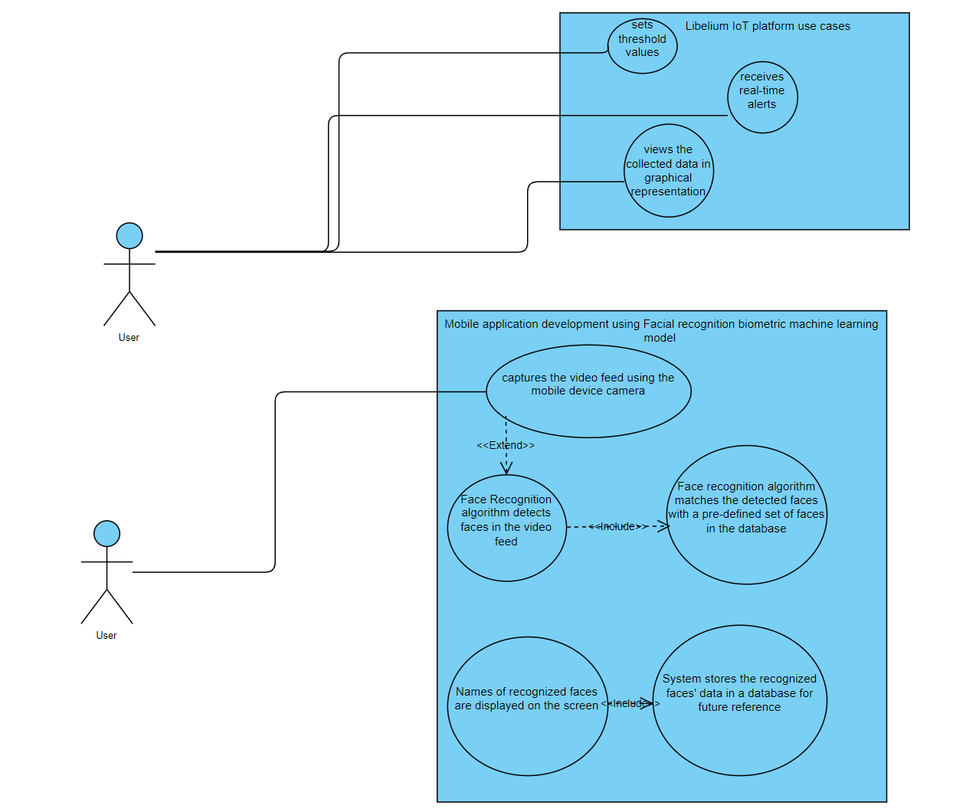

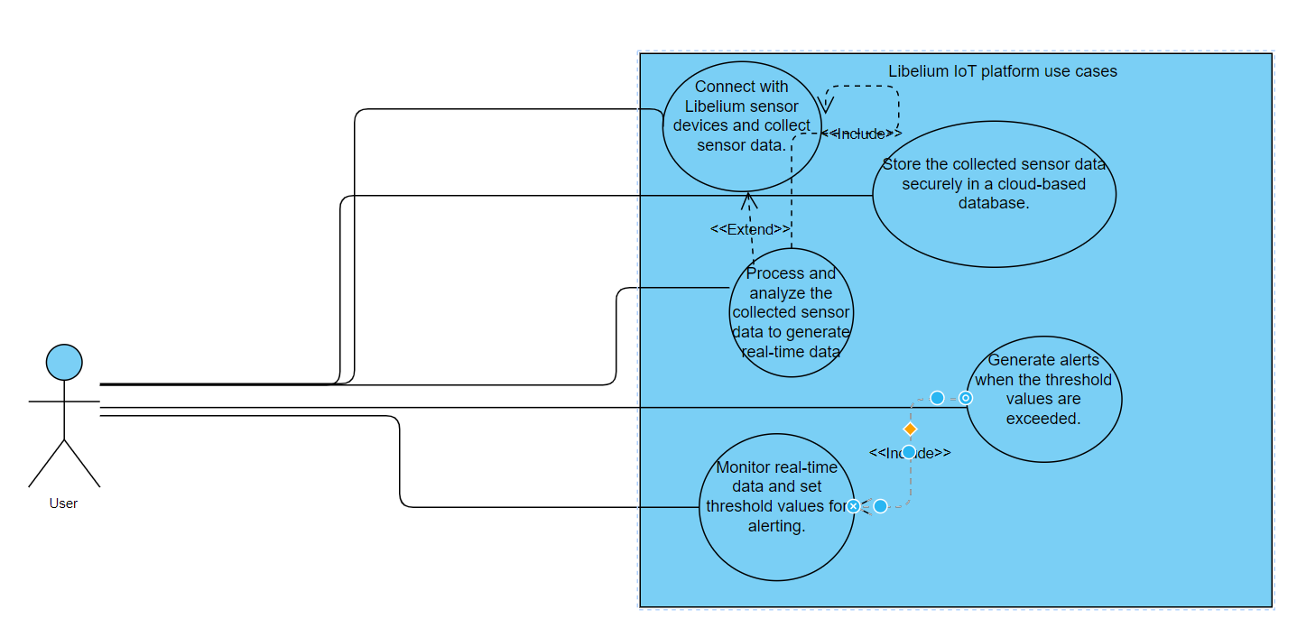

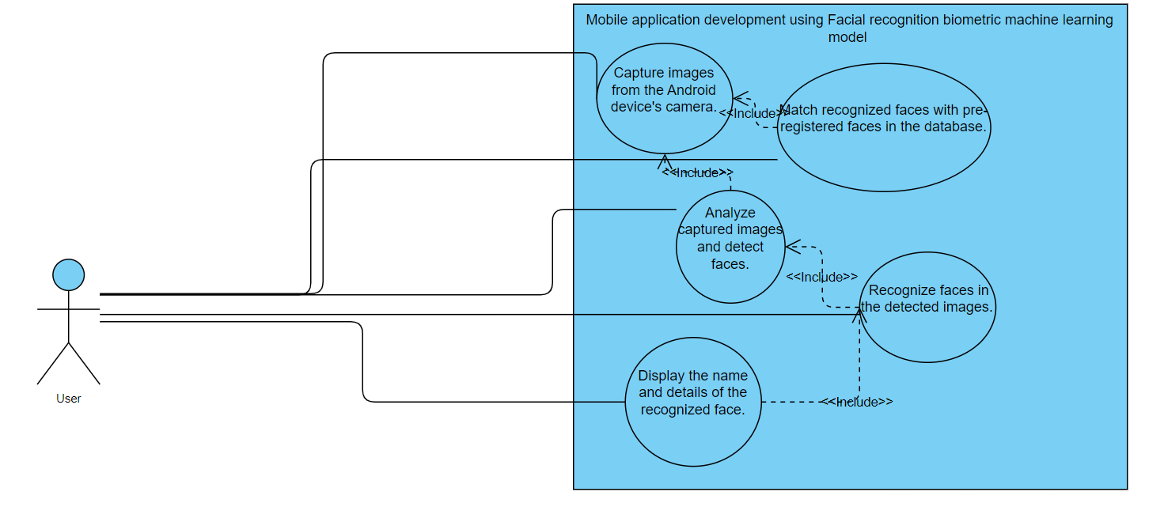

**3.3: State diagrams**

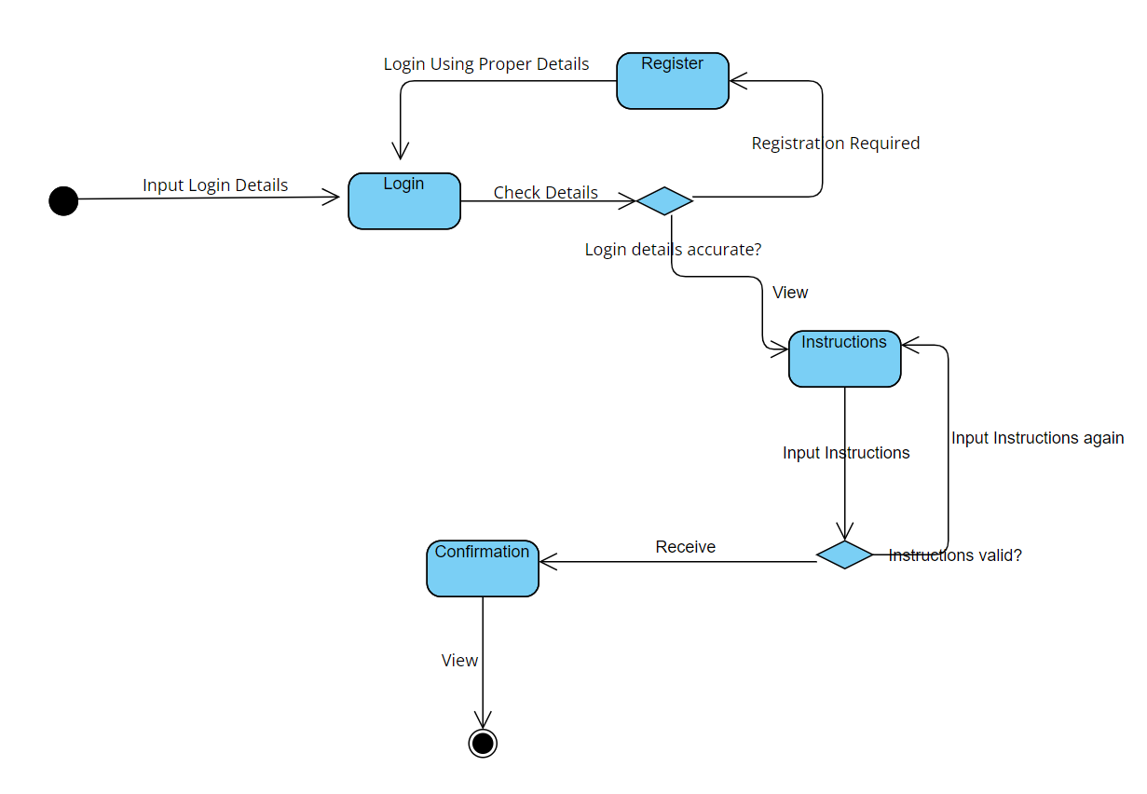

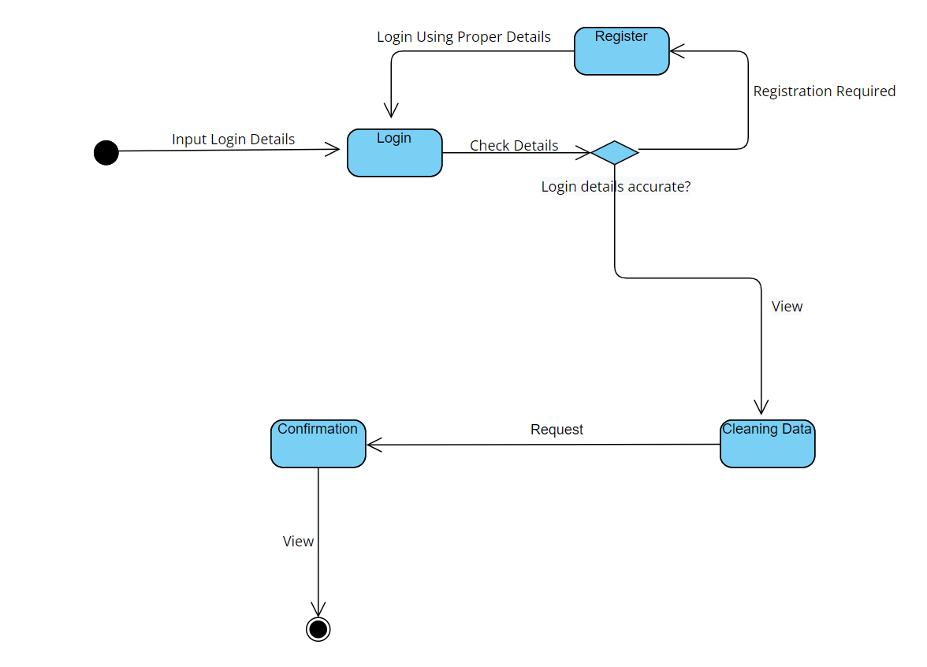

**3.4: Activity diagrams**

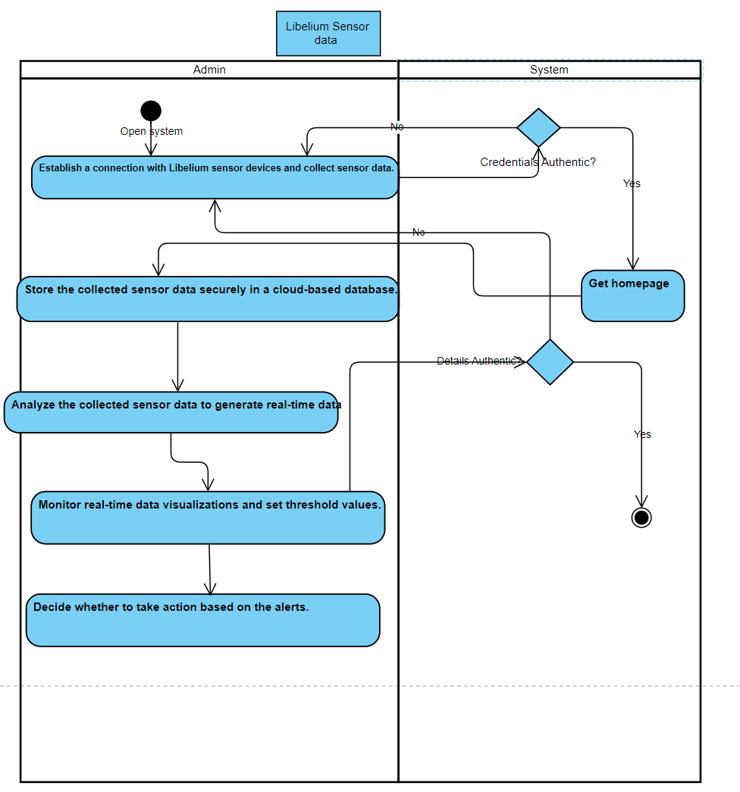

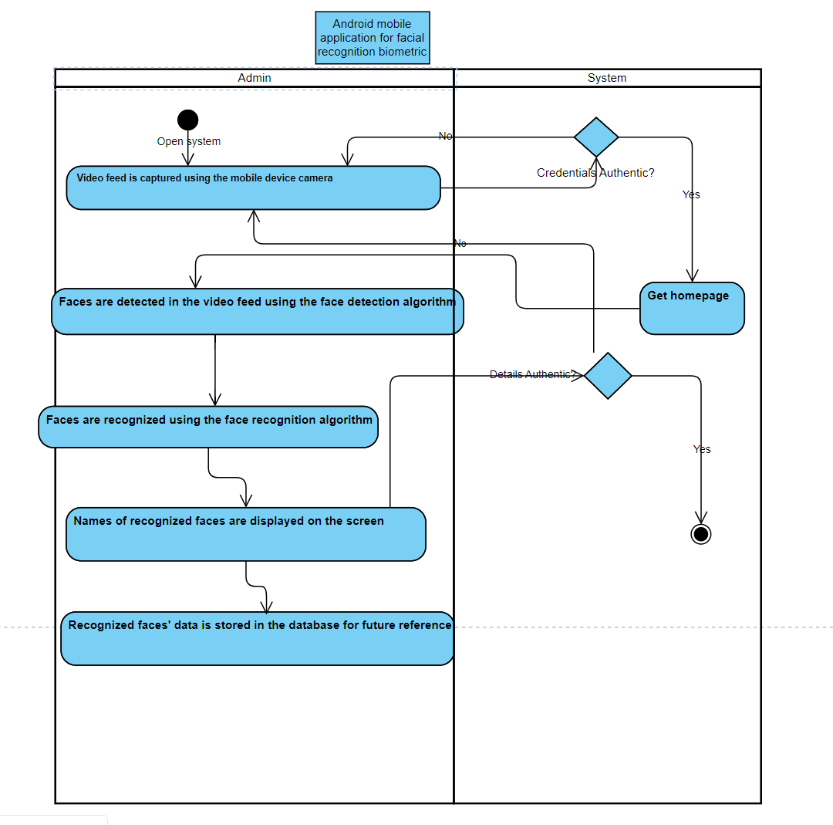

**3.5: Sequence diagram:**

**Libelium sensor data:**

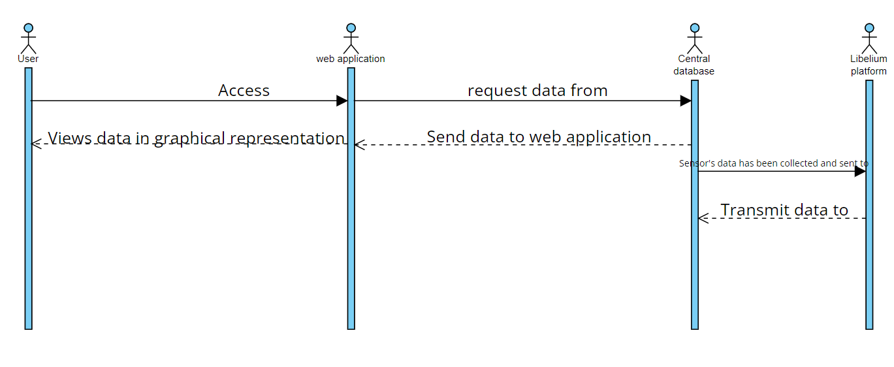

Android mobile application for facial recognition biometric:

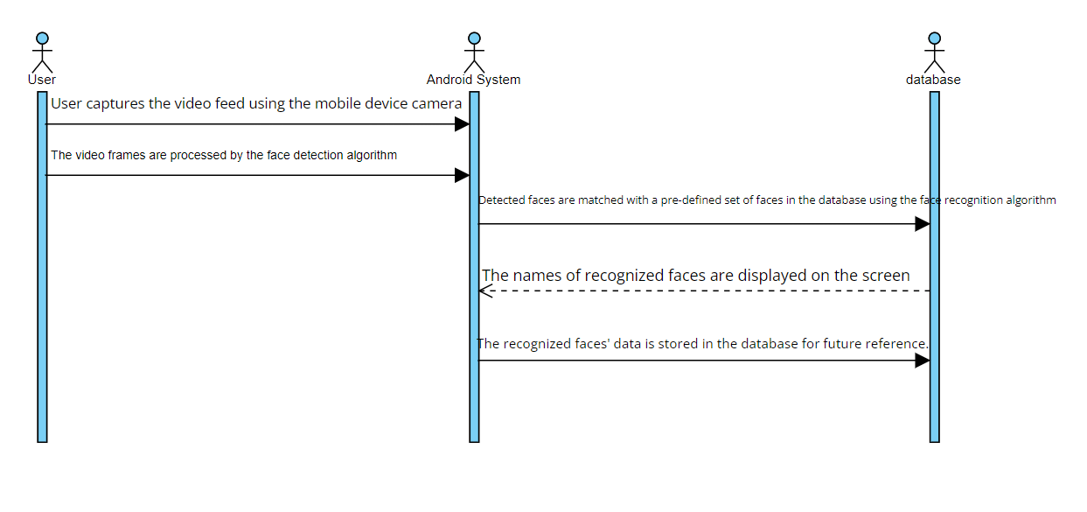

**3.5: User interface:**

**/* please be advised that the UI shown are on Emulator and android studio doesn’t allow camera visibility on Emulator , ONLY on Physical devices the camera visibility is shown where there are few more options more that you can use, but since it’s in emulator it’s these that are the available options on UI only few are not shown due to the android camera visibility */**

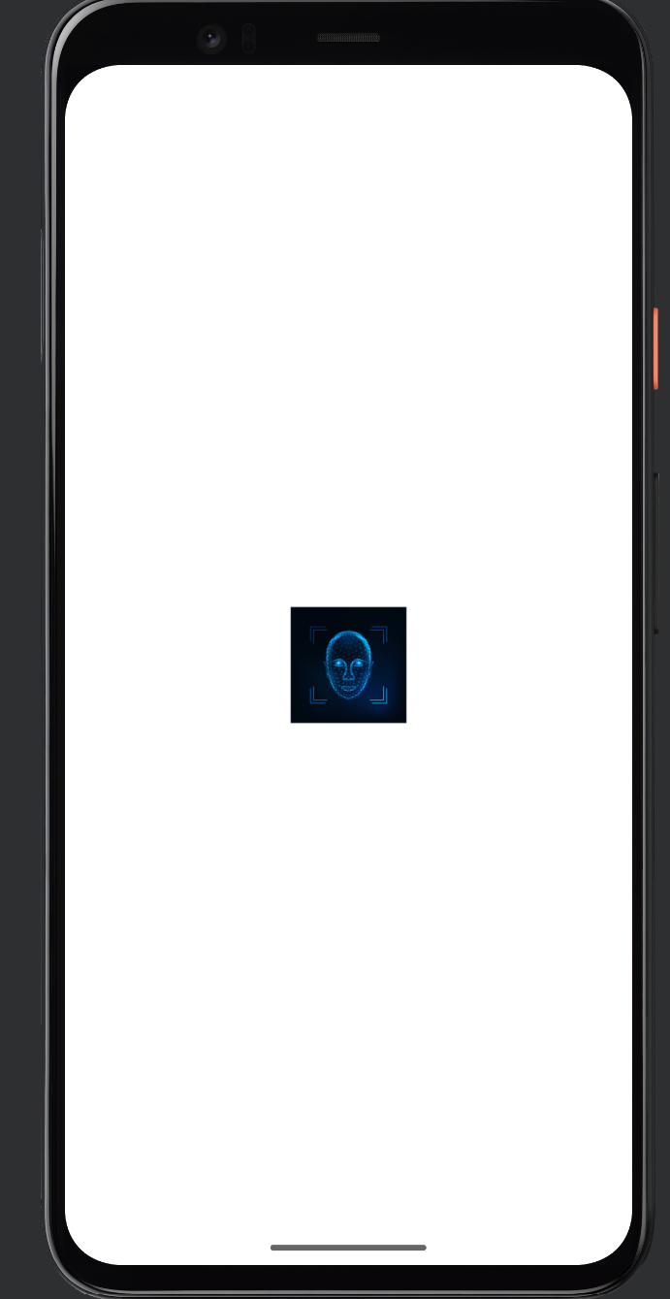

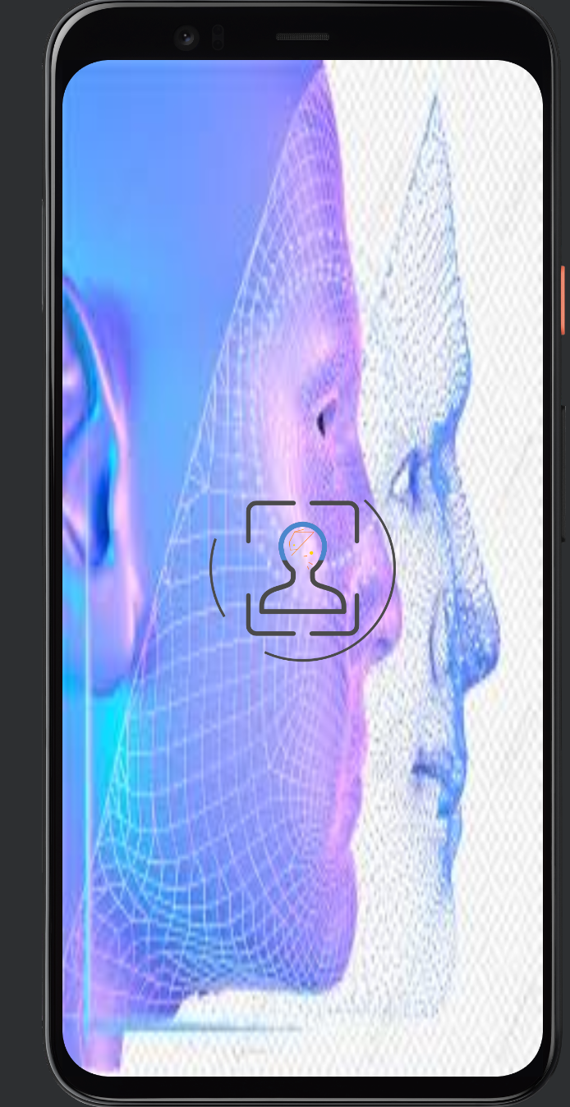

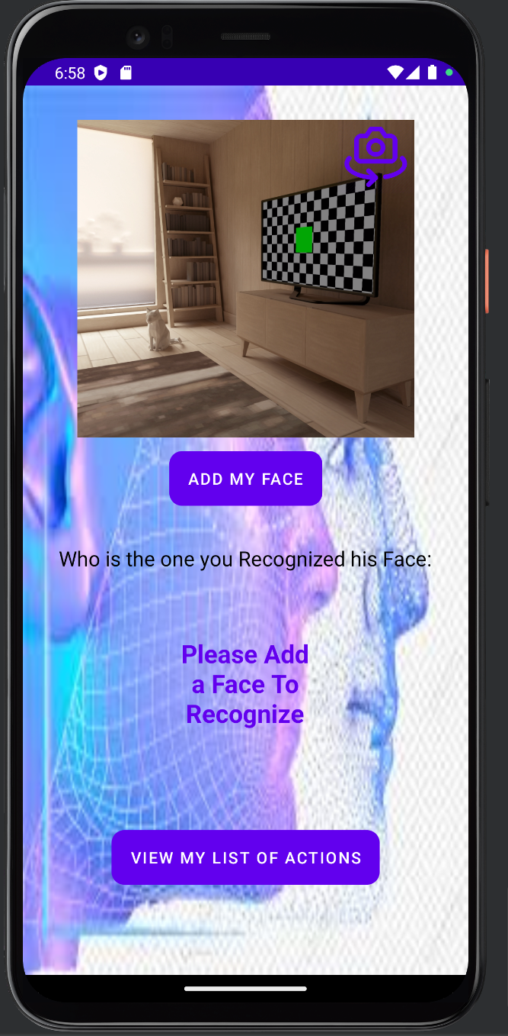

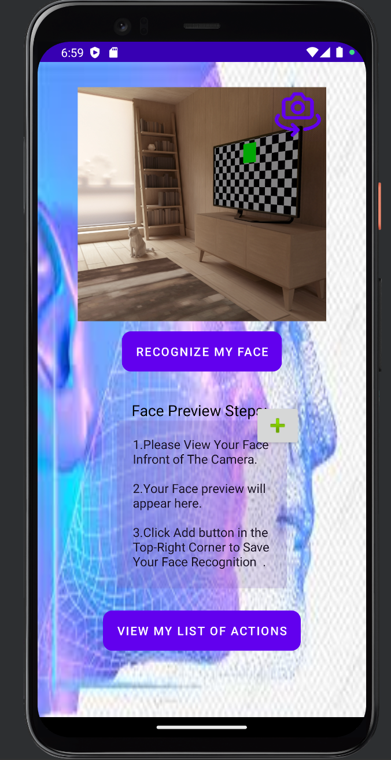

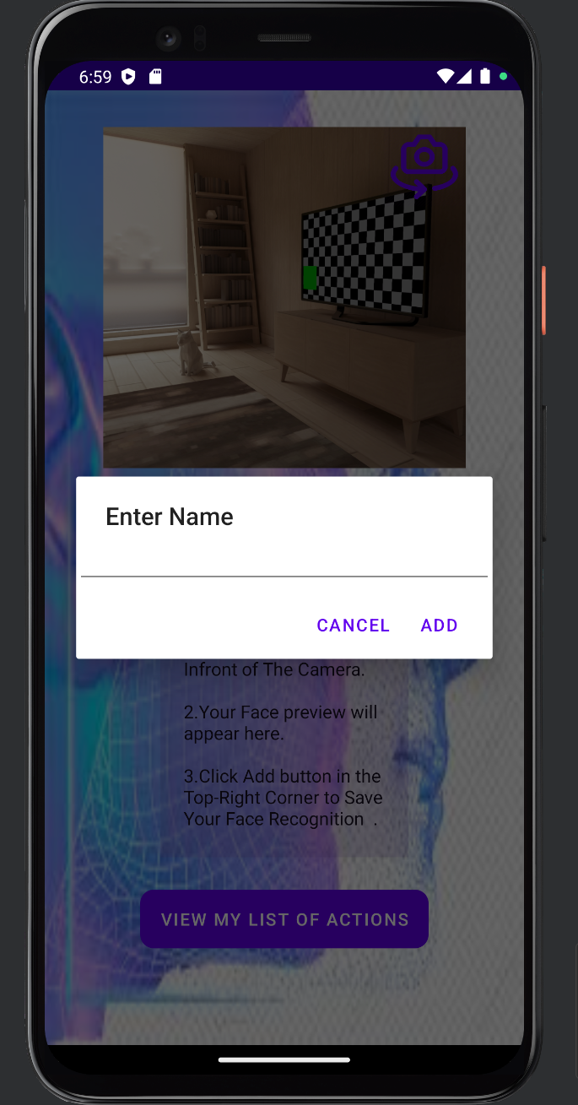

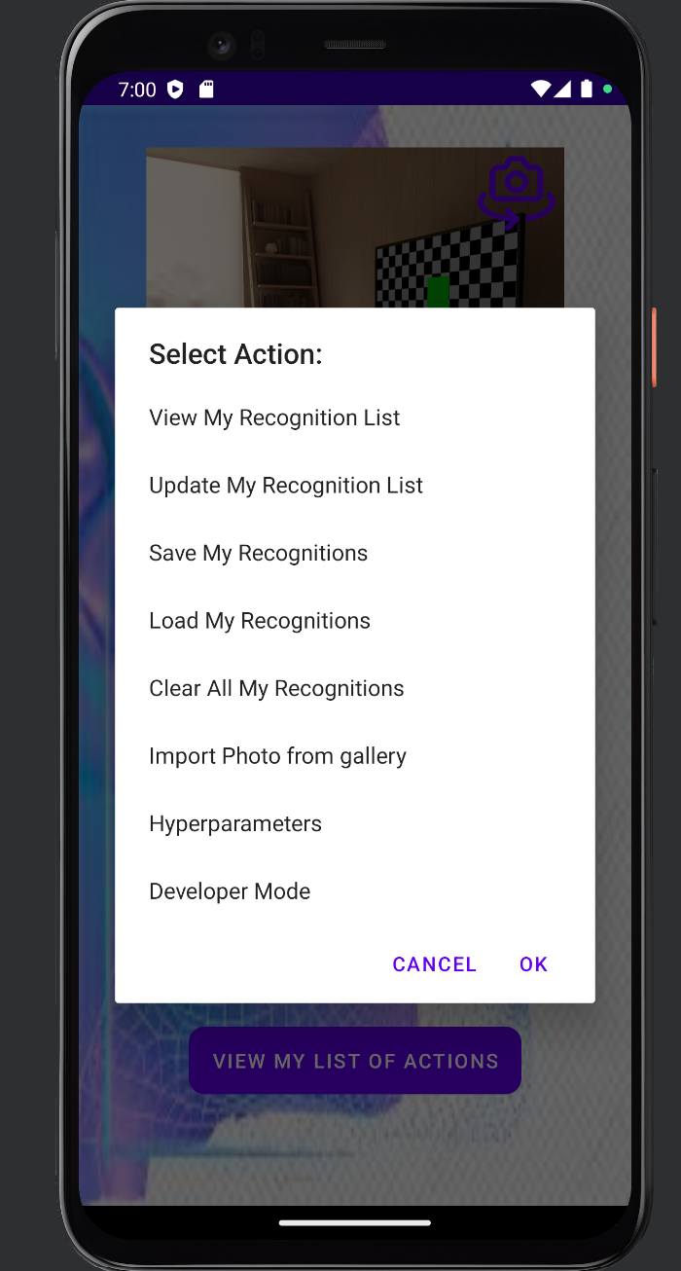

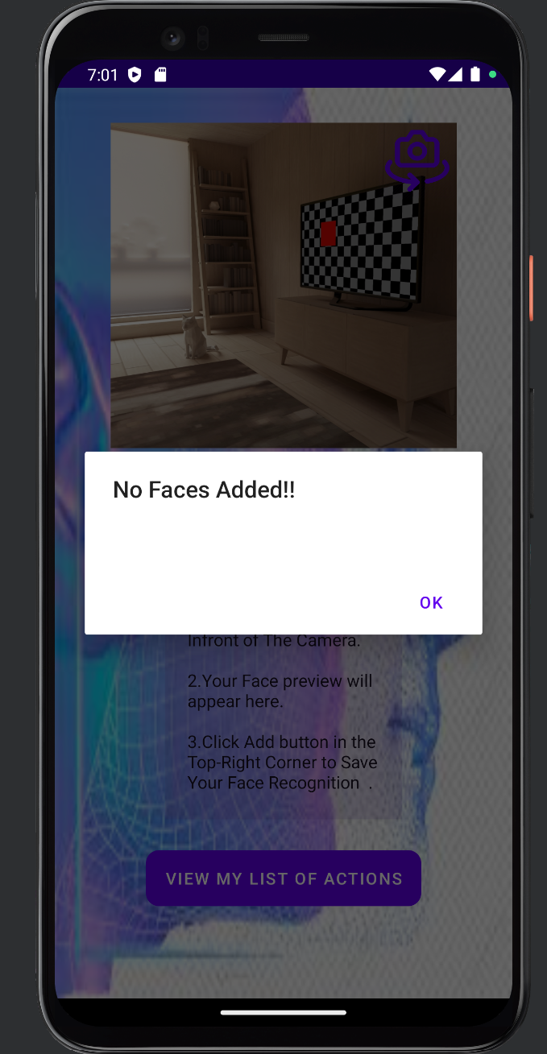

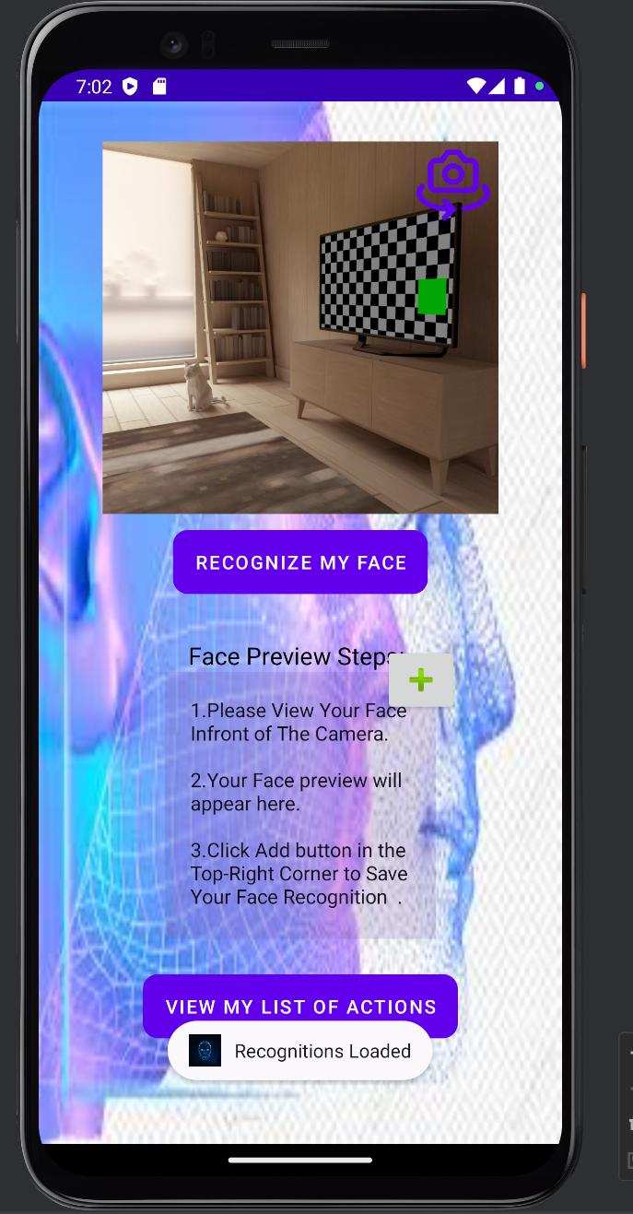

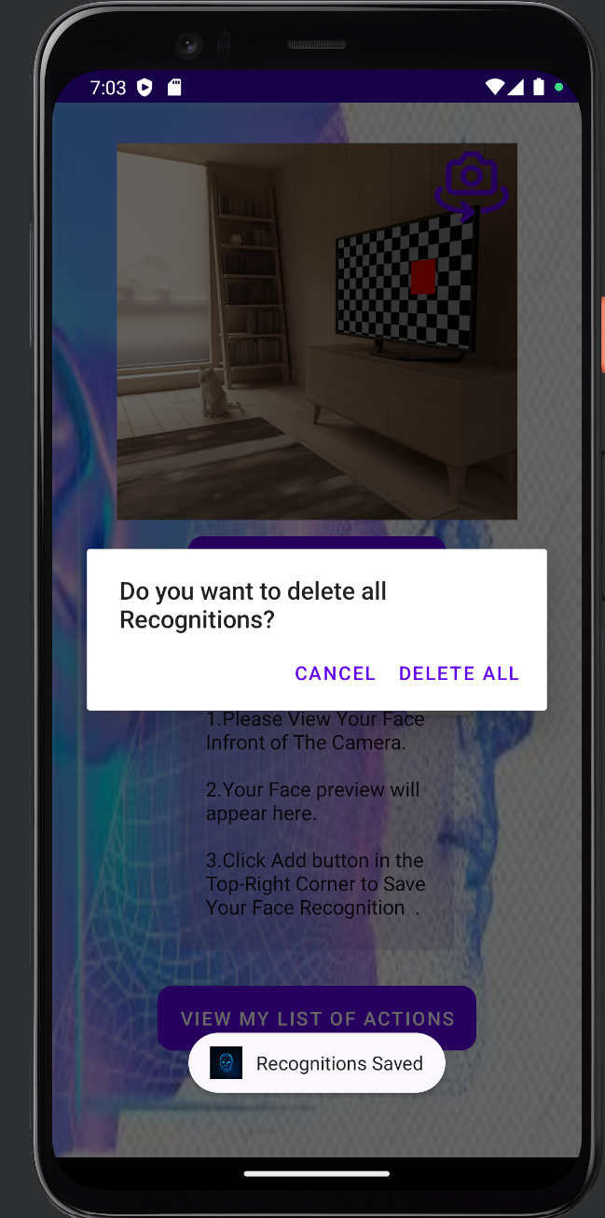

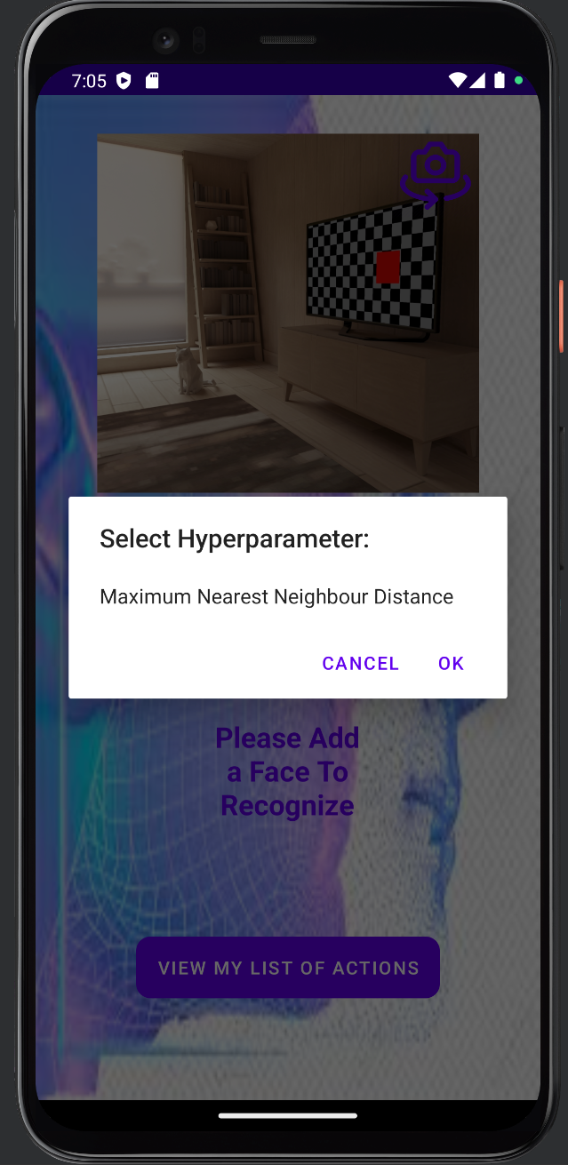

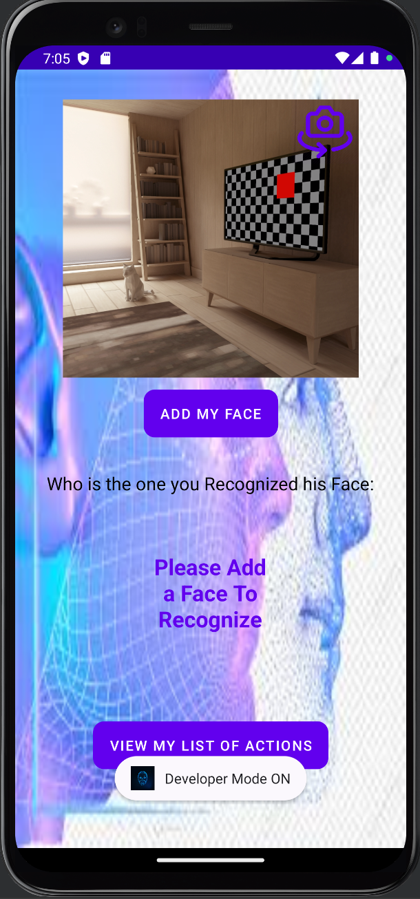

Libelium UI:

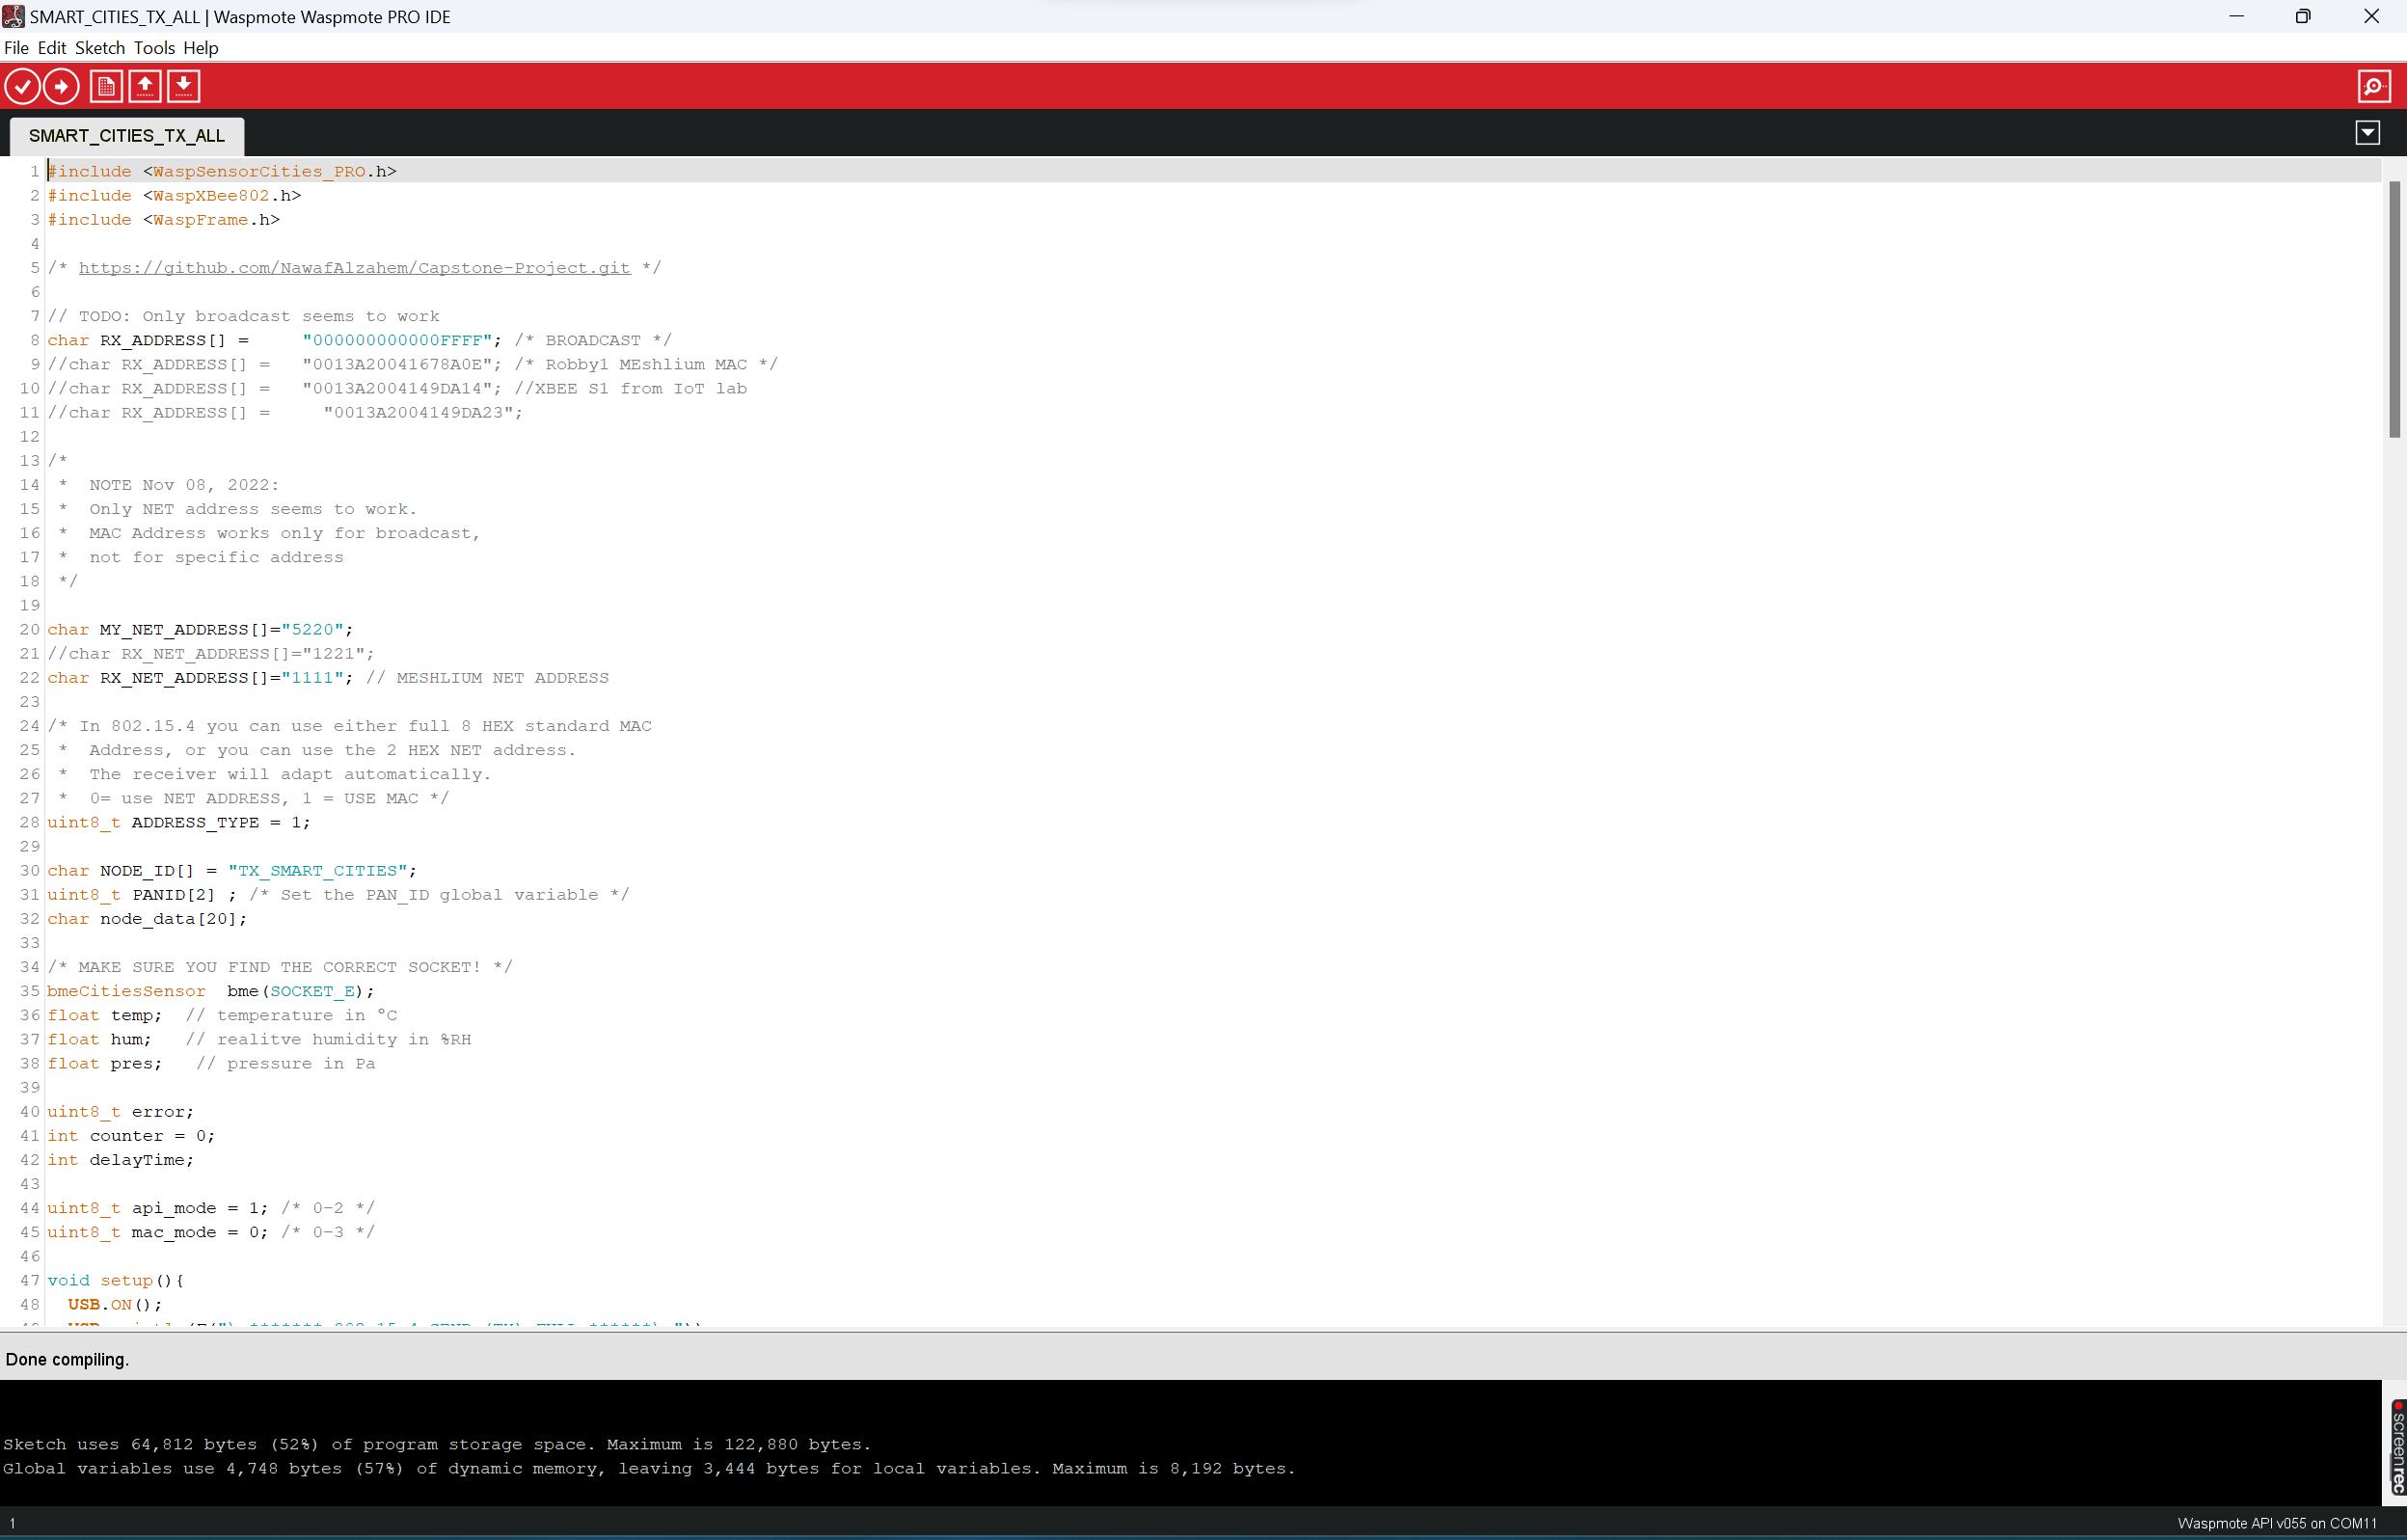

Libeium UI are all the same which is a CLI interface and . we need the motes, smart cities, and noise level sensor equipment’s to run on specific port which are these equipment on the screenshot shown below but all equipment’s are in the IoT lab so we cannot run in home only in IoT lab:

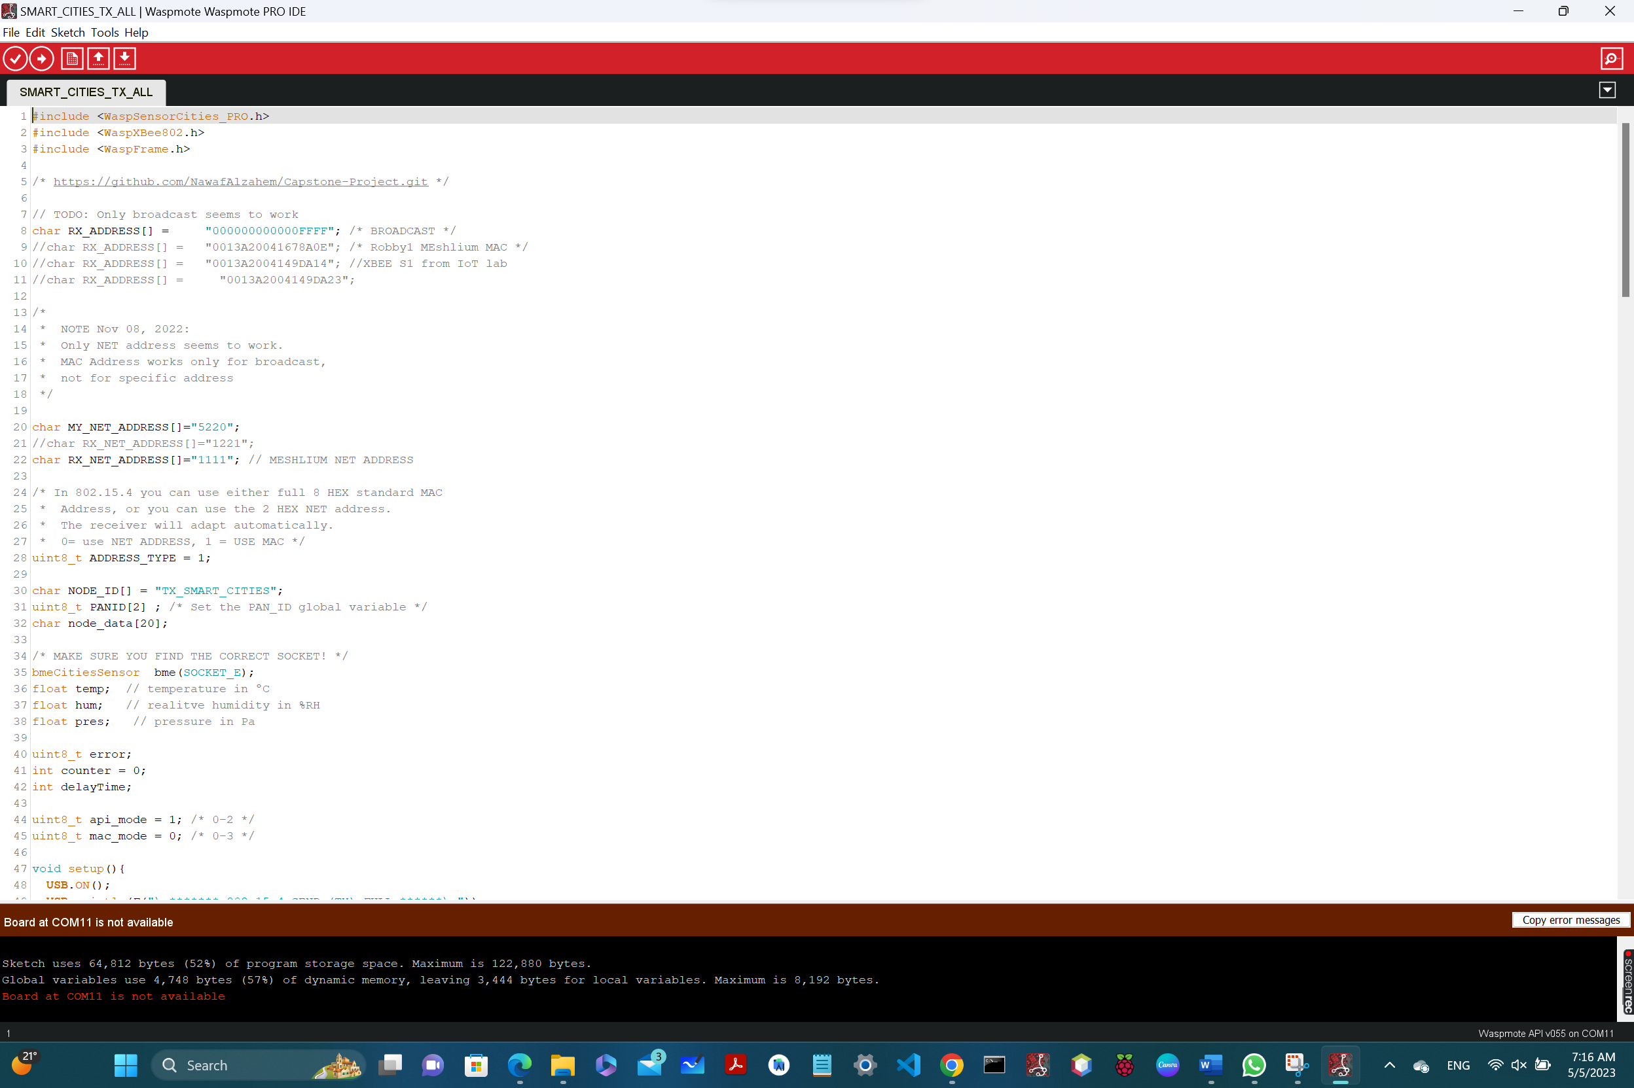

# References:

1. Asadabadi, M. R., Chang, E., Zwikael, O., Saberi, M., & Sharpe, K. (2020). Hidden fuzzy information: Requirement specification and measurement of project provider performance using the best worst method. *Fuzzy Sets and Systems*, *383*, 127-145.
2. Darnoto, B. R. P., & Siahaan, D. (2021, October). MultiPhiLDA for Detection Irrelevant Software Requirement Specification. In *2021 International Conference on Computer Science, Information Technology, and Electrical Engineering (ICOMITEE)* (pp. 92-97). IEEE.
3. Olaide, F. O., & Nyadru, I. (2018). Automated Personal Clinic Services in Uganda Software Requirement Specification.
4. Pamungkas, J. A., Priyadi, Y., & Alibasa, M. J. (2022, June). Measurement of Similarity Between Requirement Elicitation and Requirement Specification Using Text Pre-Processing in the Cinemaloka Application. In *2022 IEEE World AI IoT Congress (AIIoT)* (pp. 672-678). IEEE.
5. Raikar, S., & Cholli, N. G. (2021, December). An Analysis of Ambiguity Detection Techniques for Software Requirement Specification. In *2021 IEEE International Conference on Computation System and Information Technology for Sustainable Solutions (CSITSS)* (pp. 1-4). IEEE.
6. SABRIYE, A. O. J. A., & Zainon, W. M. N. W. (2018). AN APPROACH FOR DETECTING SYNTAX AND SYNTACTIC AMBIGUITY IN SOFTWARE REQUIREMENT SPECIFICATION. *journal of theoretical & applied information technology*, *96*(8).
7. Susilowati, M., Ahsan, M., & Kurniawan, Y. (2019, December). What does the software requirement specification for local E-Government of citizen database information system? An analysis using ISO/IEC/IEEE 29148–2011. In *Journal of Physics: Conference Series* (Vol. 1402, No. 2, p. 022087). IOP Publishing.
8. Vineetha, K. V., & Samuel, P. (2022, June). A Multinomial Naïve Bayes Classifier for identifying Actors and Use Cases from Software Requirement Specification documents. In *2022 2nd International Conference on Intelligent Technologies (CONIT)* (pp. 1-5). IEEE.